432 Class 24

https://thomaselove.github.io/432-2025

2025-04-10

## Today’s Agenda

A brief introduction to …

* K-Means Clustering
* Principal Components Analysis

Examples:

1. The 4000 biggest cities in the world
2. The Palmer Penguins
3. Arrest Rates in US States

## Today’s R Setup

knitr::opts_chunk$set(comment=NA)  
  
library(janitor)  
library(conflicted)  
library(naniar)  
library(palmerpenguins)  
library(mdsr) # for the world_cities data set  
library(tidymodels)  
library(easystats)  
library(tidyverse)  
  
conflicts_prefer(palmerpenguins::penguins)  
  
theme_set(theme_bw())

# Clustering the 4,000 Biggest Cities in the World

## World Cities Data

* We’ll start with an example from section 9.1.2 of Baumer, Kaplan and Horton’s *Modern Data Science with R*.

BigCities <- world_cities |>  
 arrange(desc(population)) |>  
 head(4000) |>  
 select(longitude, latitude)  
  
glimpse(BigCities)

Rows: 4,000  
Columns: 2  
$ longitude <dbl> 121.45806, 28.94966, -58.37723, 72.88261, -99.12766, 116.397…  
$ latitude <dbl> 31.22222, 41.01384, -34.61315, 19.07283, 19.42847, 39.90750,…

## Cluster by the 6-means algorithm

set.seed(432)  
city_clusts <- BigCities |>  
 kmeans(centers = 6) |>  
 fitted("classes") |>  
 as.character()  
  
BigCities <- BigCities |>  
 mutate(cluster = city_clusts)  
  
head(BigCities, 2)

# A tibble: 2 × 3  
 longitude latitude cluster  
 <dbl> <dbl> <chr>   
1 121. 31.2 6   
2 28.9 41.0 4

## Map the cities and color by clusters

ggplot(BigCities, aes( x = longitude, y = latitude)) +   
 geom_point(aes(color = cluster), alpha = 0.5)

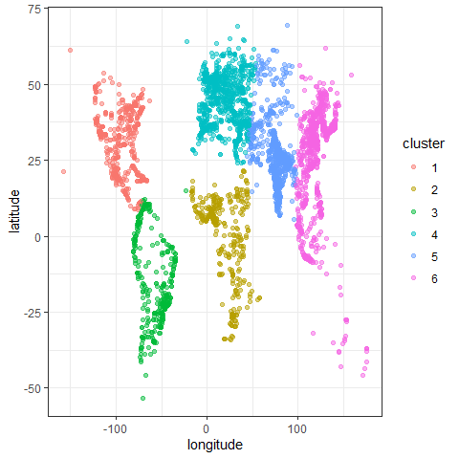

* The clustering algorithm has (essentially) identified the continents.

## How does K-Means Clustering Work?

You can visit <https://www.tidymodels.org/learn/statistics/k-means/> for a brief explanation of the clustering process using an animation from Allison Horst. Here, I’ll look at the pieces one slide at a time.

Allison’s materials are available at <https://github.com/allisonhorst/stats-illustrations/tree/master/other-stats-artwork>

## From Allison Horst (1/11)

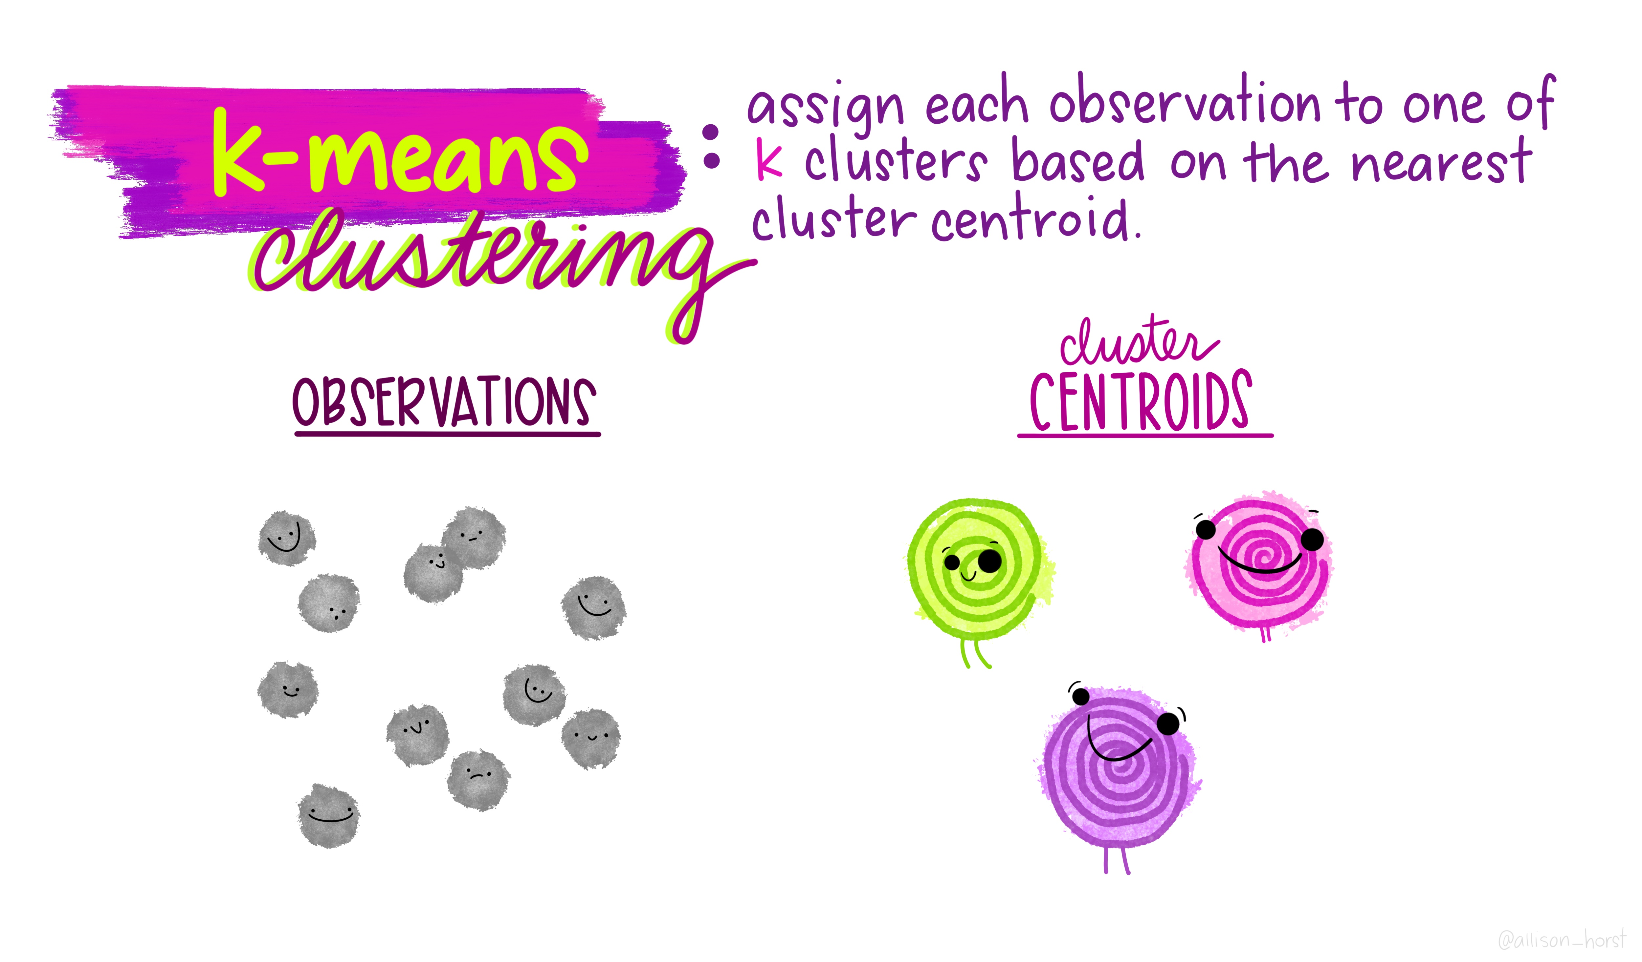

## From Allison Horst (2/11)

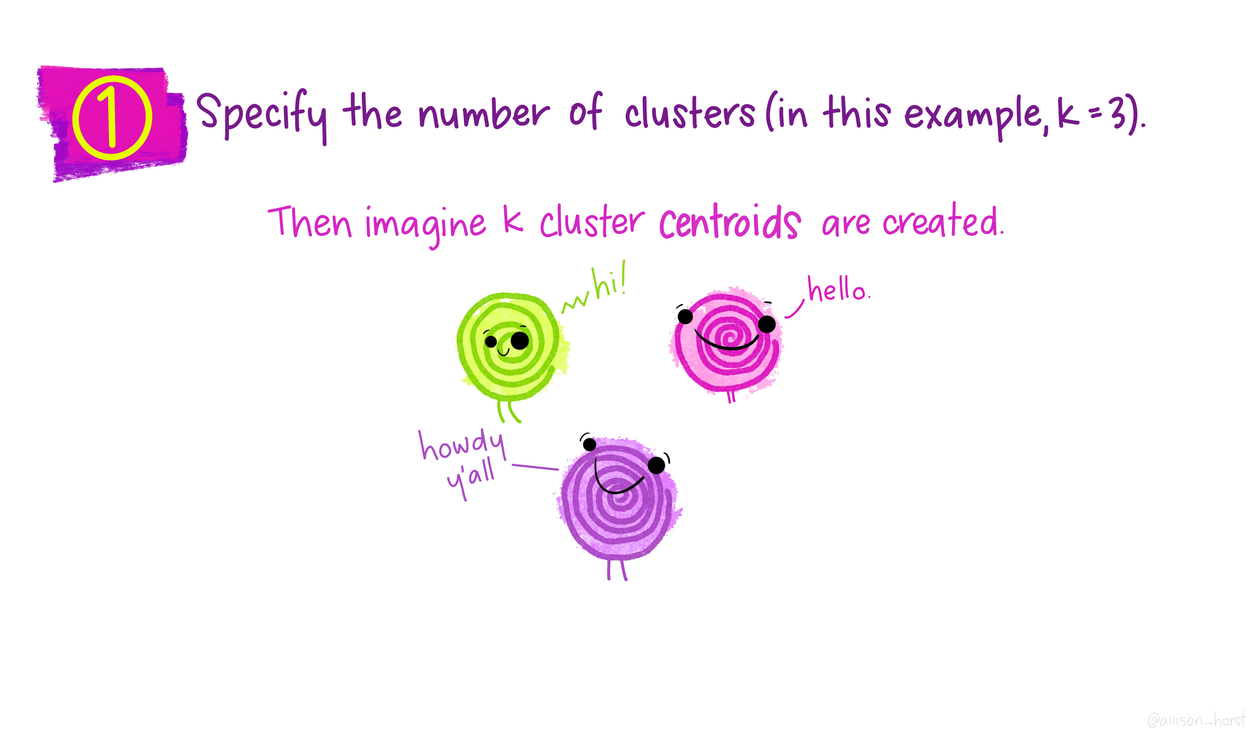

## From Allison Horst (3/11)

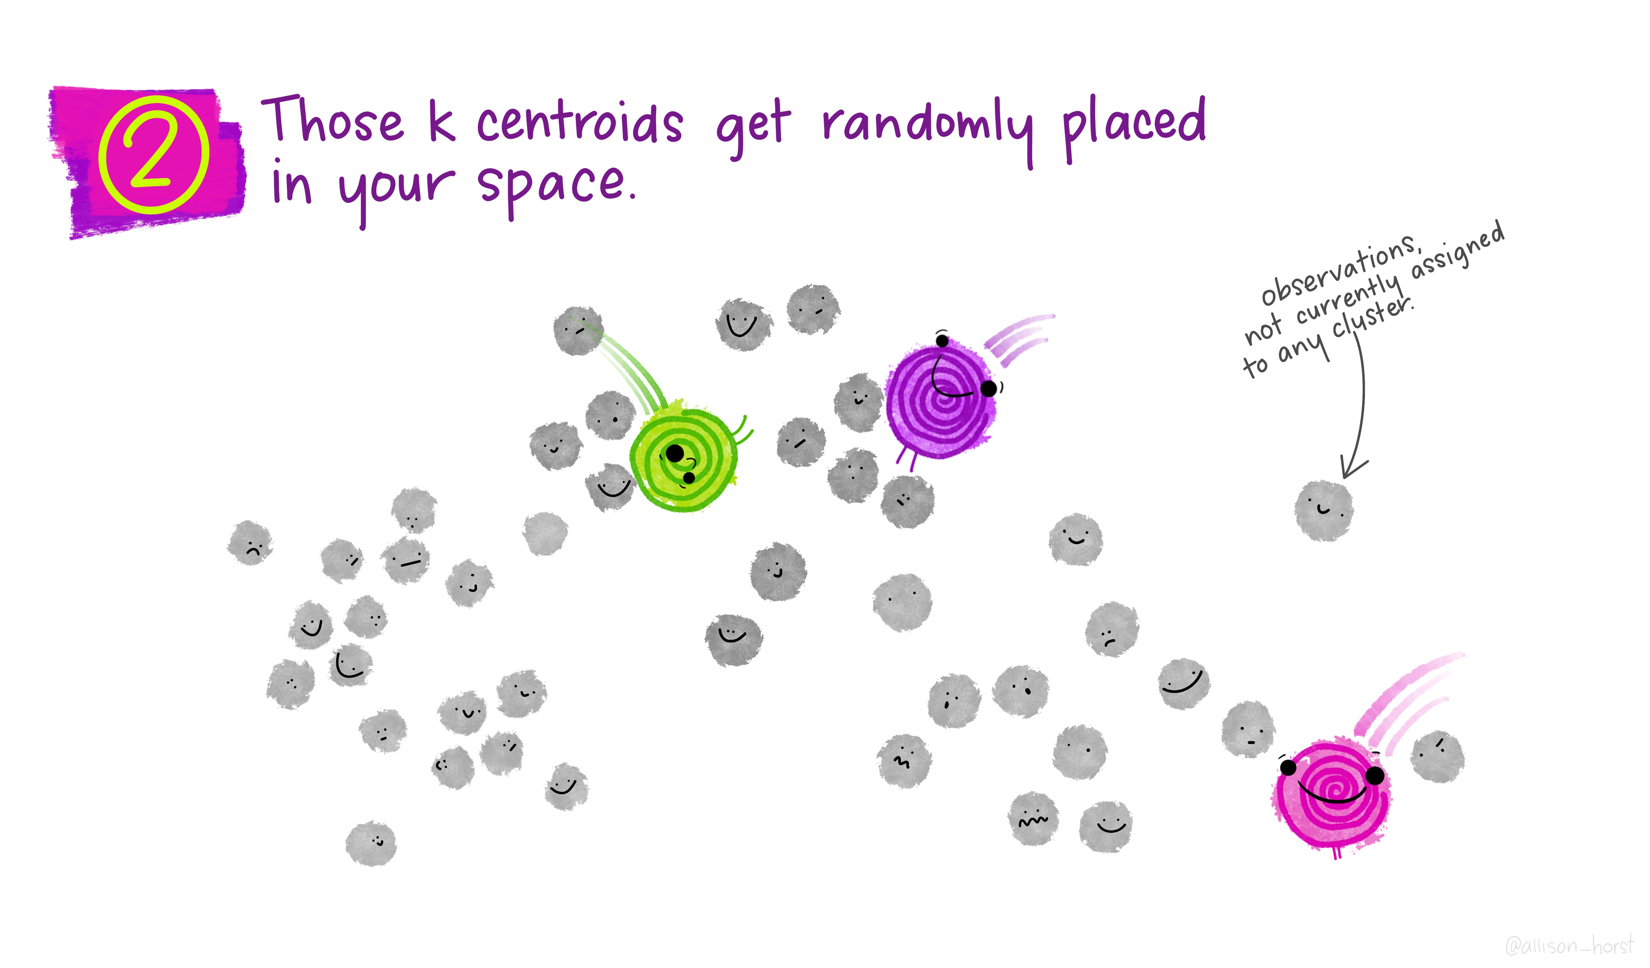

## From Allison Horst (4/11)

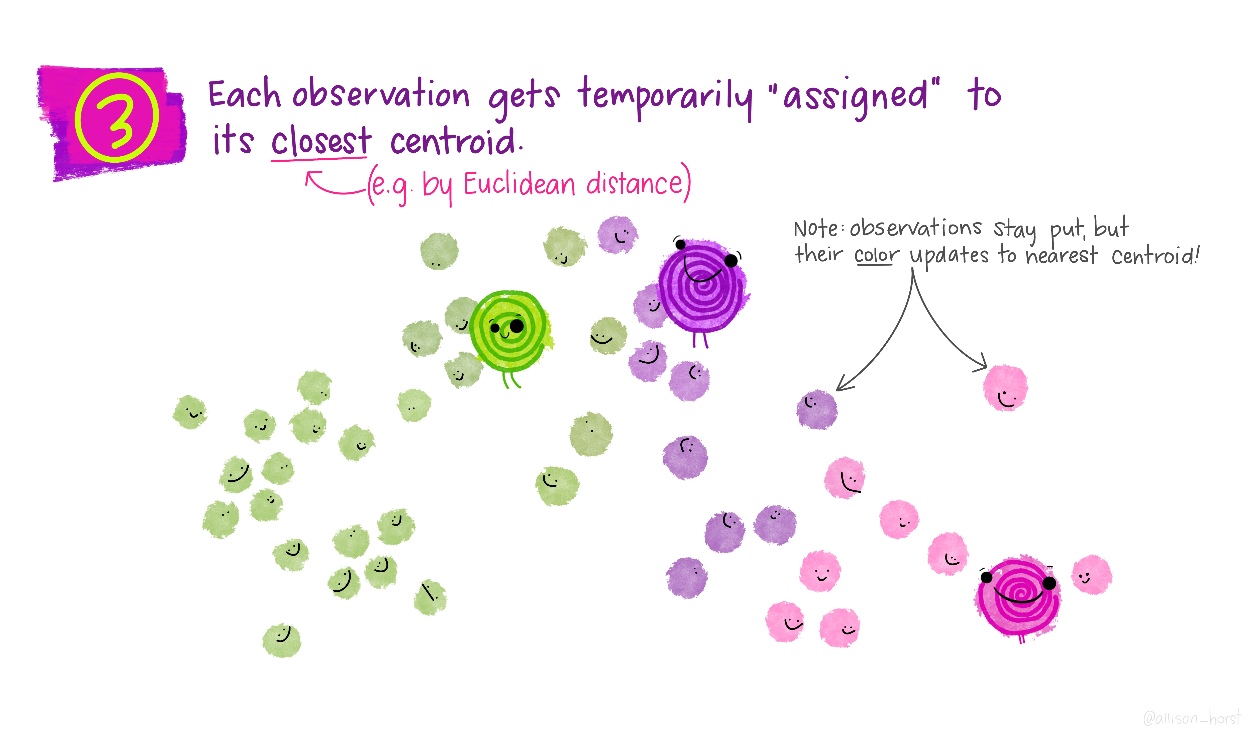

## From Allison Horst (5/11)

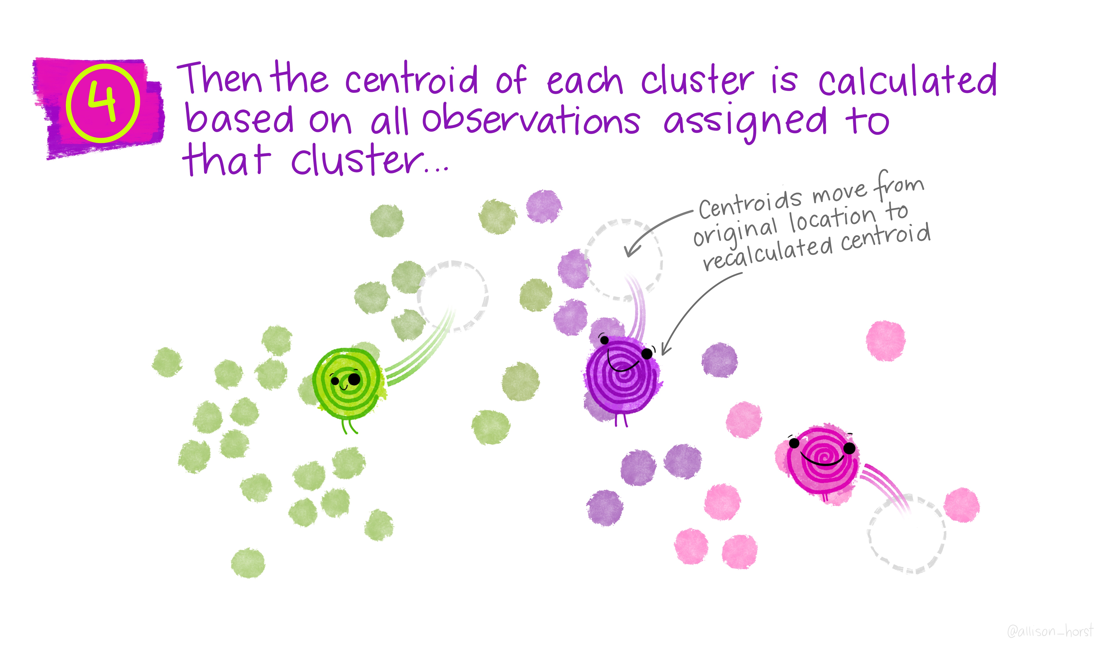

## From Allison Horst (6/11)

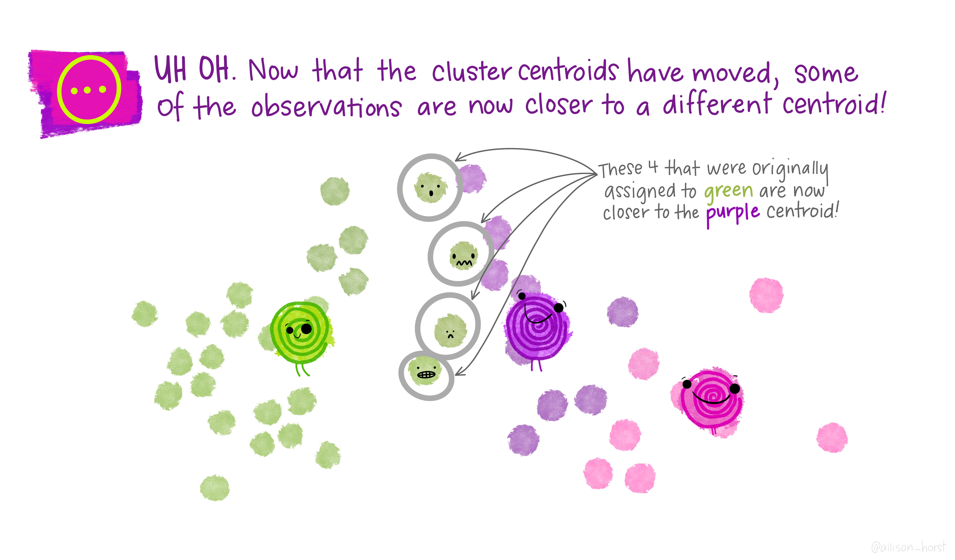

## From Allison Horst (7/11)

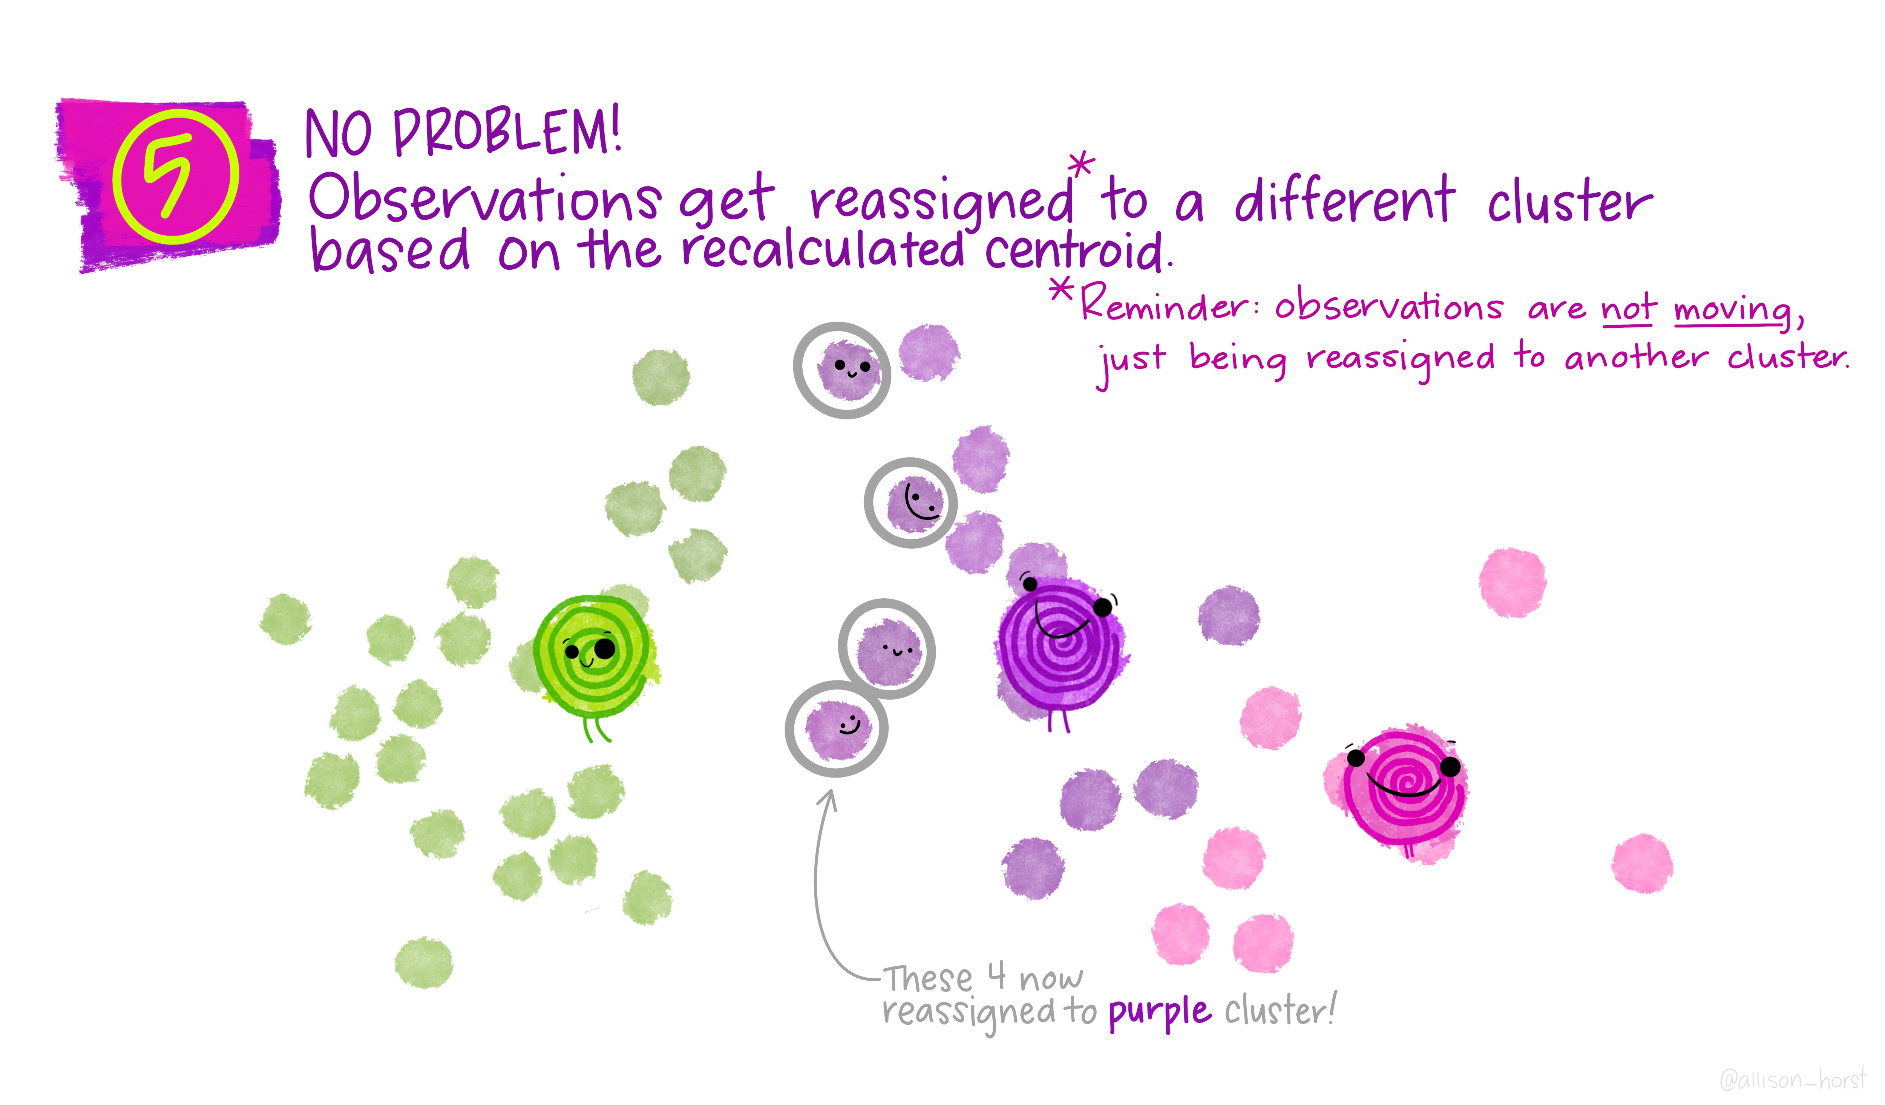

## From Allison Horst (8/11)

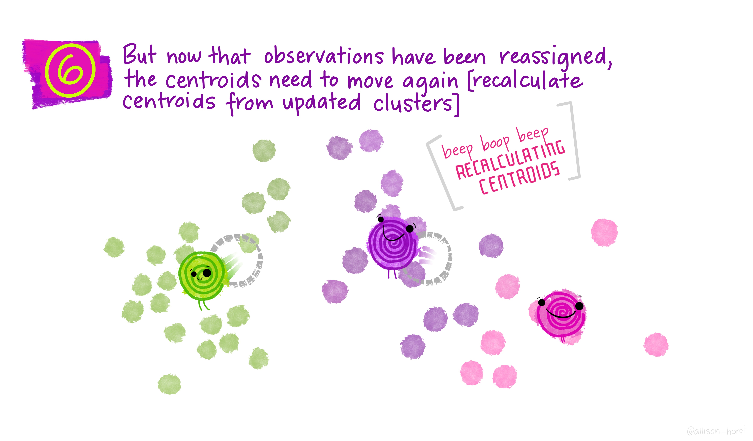

## From Allison Horst (9/11)

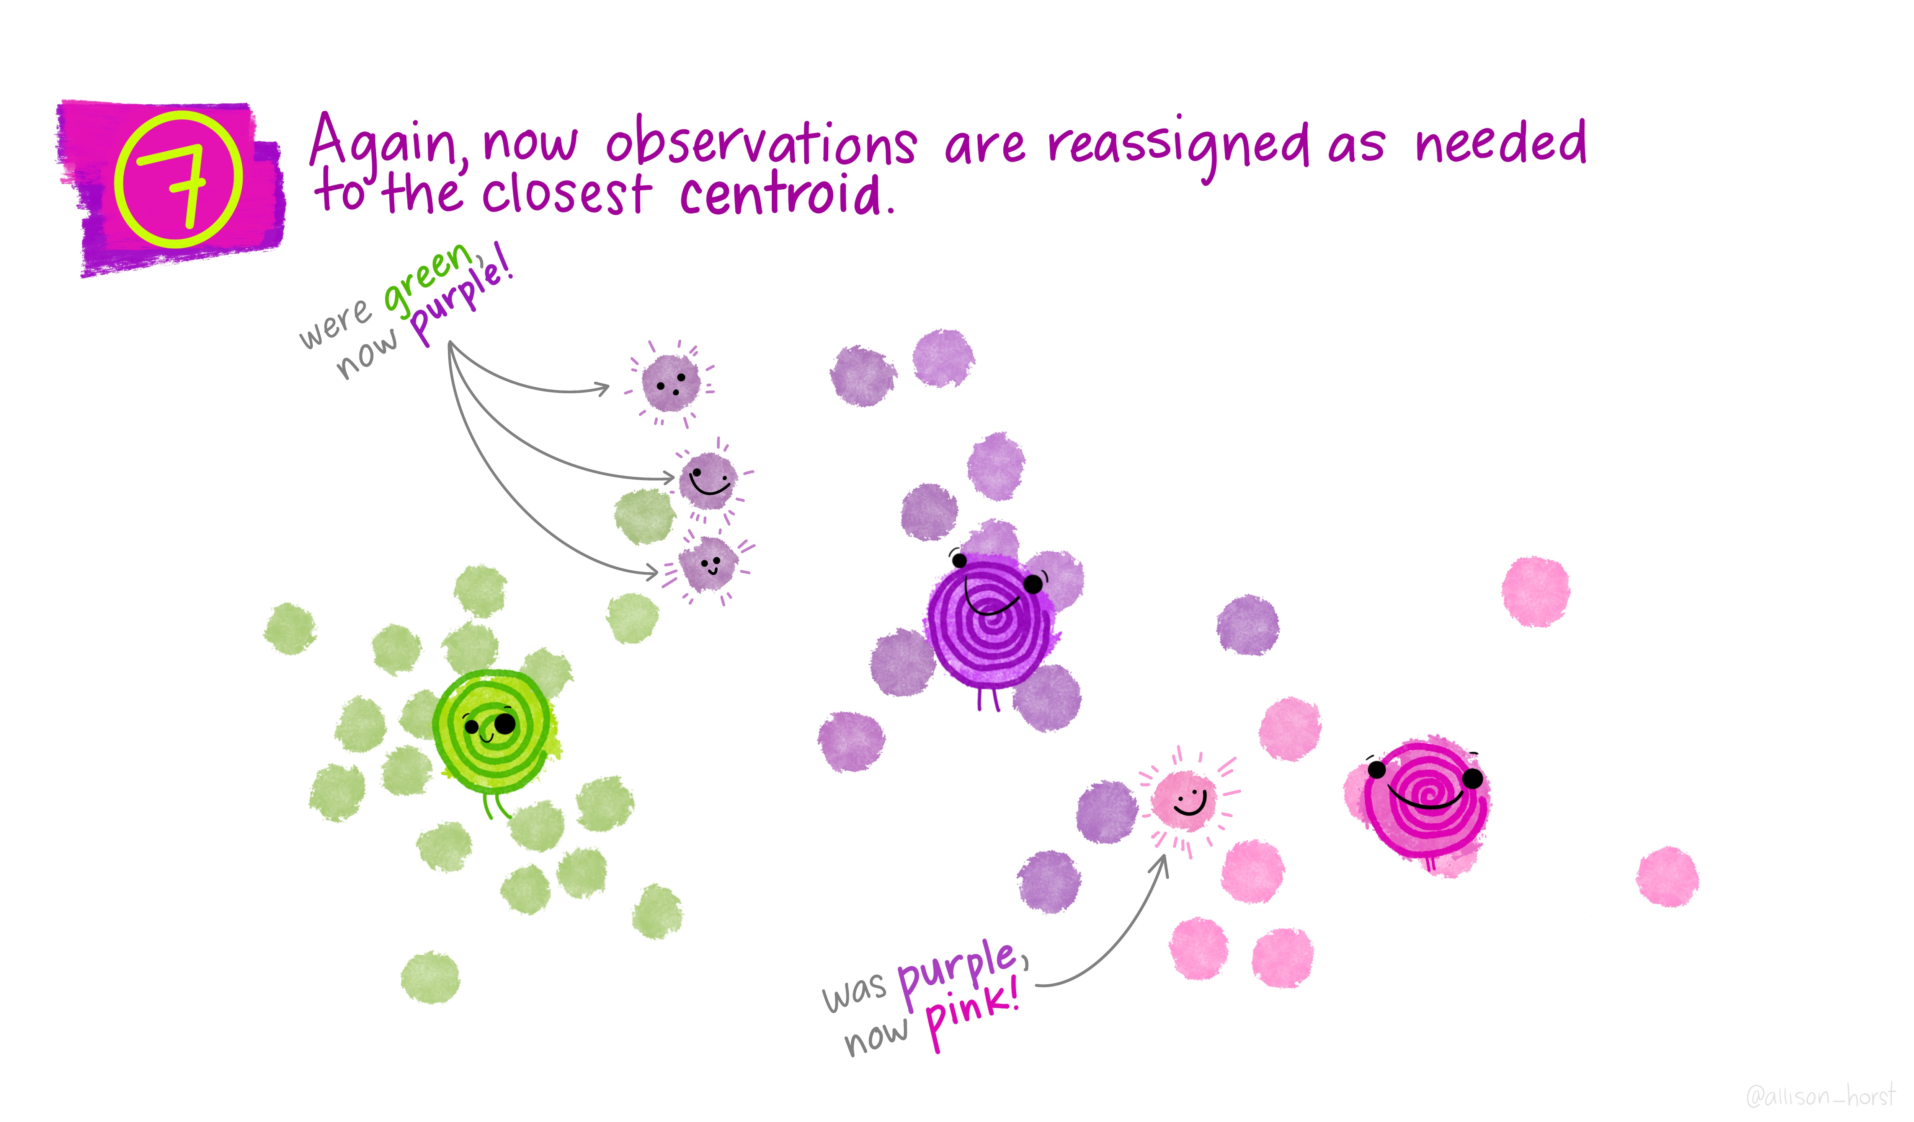

## From Allison Horst (10/11)

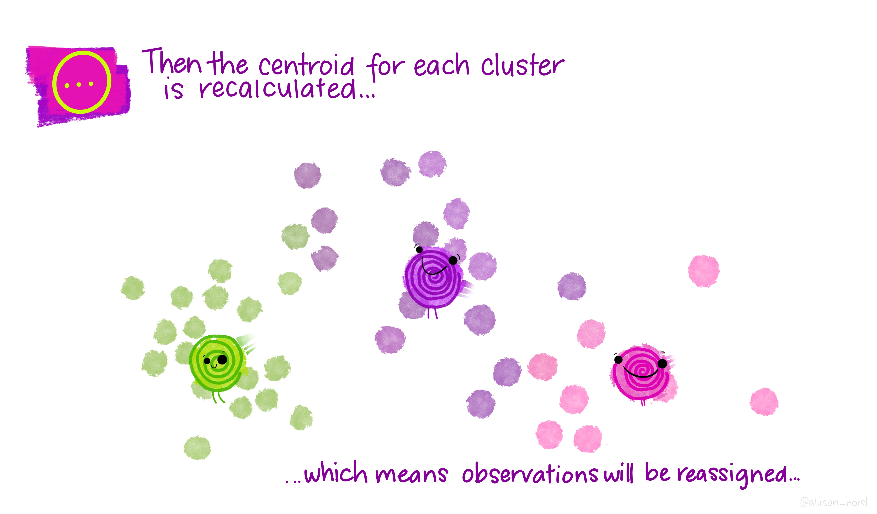

## From Allison Horst (11/11)

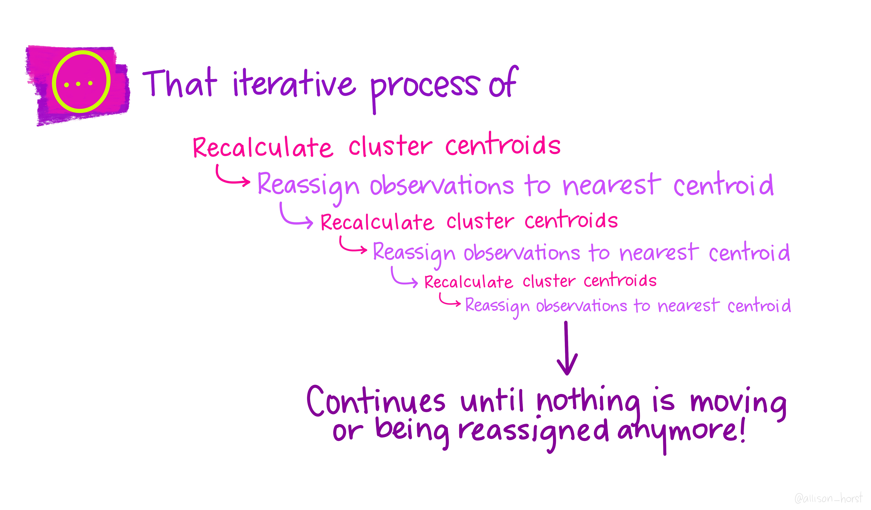

## The Palmer Penguins

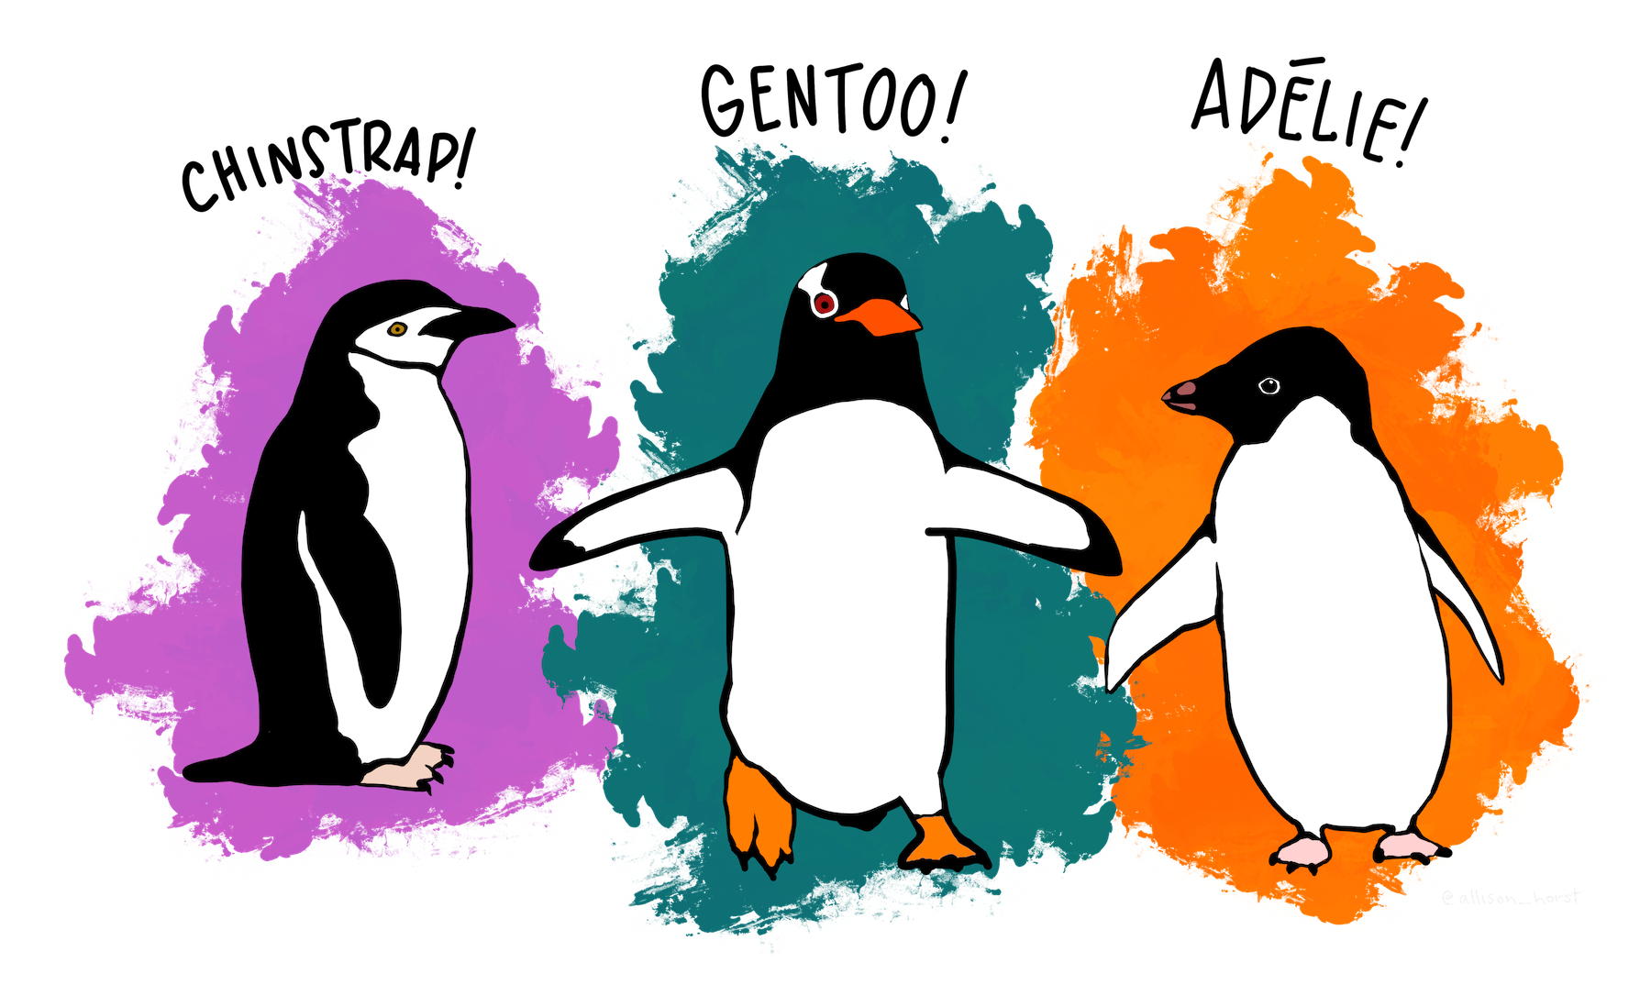

## The Palmer Penguins

pen <- penguins |> ## from palmerpenguins package  
 select(bill_length_mm, bill_depth_mm, species) |>  
 drop_na()  
  
glimpse(pen)

Rows: 342  
Columns: 3  
$ bill_length_mm <dbl> 39.1, 39.5, 40.3, 36.7, 39.3, 38.9, 39.2, 34.1, 42.0, 3…  
$ bill_depth_mm <dbl> 18.7, 17.4, 18.0, 19.3, 20.6, 17.8, 19.6, 18.1, 20.2, 1…  
$ species <fct> Adelie, Adelie, Adelie, Adelie, Adelie, Adelie, Adelie,…

## What is being measured?

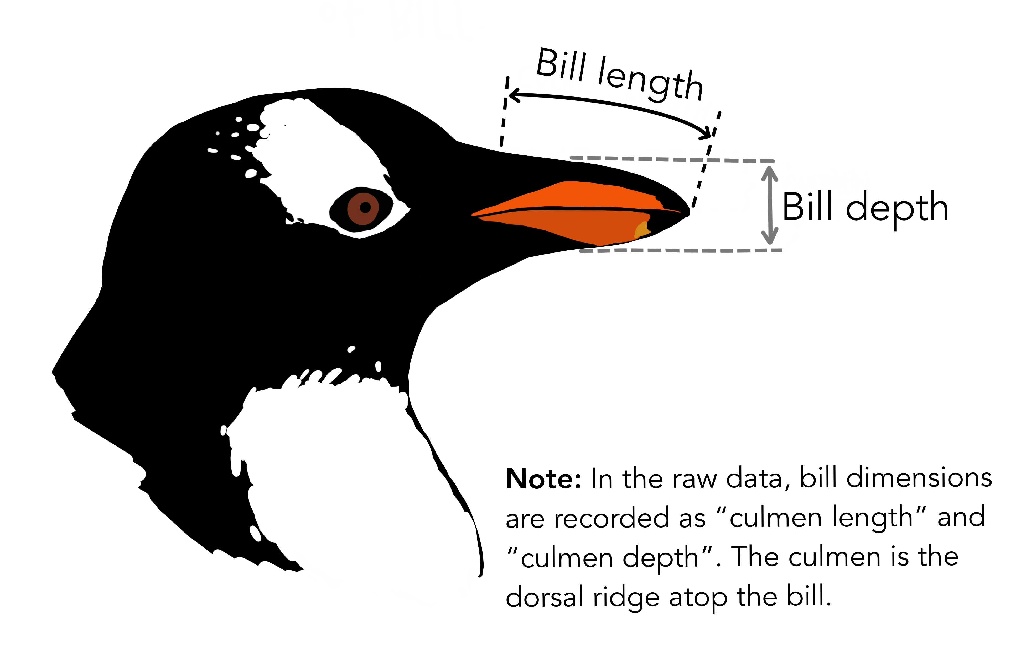

## Getting Started

1. Create a data set with only numeric variables

pen1 <- pen |> select(-species)

1. Scale each variable to have mean 0 and sd 1

pen1 <- pen1 |> scale()  
  
summary(pen1)

bill_length_mm bill_depth_mm   
 Min. :-2.16535 Min. :-2.05144   
 1st Qu.:-0.86031 1st Qu.:-0.78548   
 Median : 0.09672 Median : 0.07537   
 Mean : 0.00000 Mean : 0.00000   
 3rd Qu.: 0.83854 3rd Qu.: 0.78430   
 Max. : 2.87166 Max. : 2.20217

## Decide on the number of clusters, then run k-means

We know there are three types of penguins included, so let’s try $k$ = 3.

pen_clust <- kmeans(pen1, centers = 3)  
pen_clust

K-means clustering with 3 clusters of sizes 153, 64, 125  
  
Cluster means:  
 bill_length_mm bill_depth_mm  
1 -0.9431819 0.5595723  
2 1.1018368 0.7985421  
3 0.5903143 -1.0937700  
  
Clustering vector:  
 [1] 1 1 1 1 1 1 1 1 1 1 1 1 1 1 1 1 1 1 2 1 1 1 1 1 1 1 1 1 1 1 1 1 1 1 1 1 1  
 [38] 1 1 1 1 1 2 1 1 1 1 1 1 1 1 1 1 1 1 1 1 1 1 1 1 1 1 1 1 1 1 1 1 1 1 1 2 1  
 [75] 1 1 1 1 1 1 1 1 1 1 1 1 1 1 1 1 1 1 1 1 1 1 1 1 1 1 1 1 1 1 1 1 1 1 1 1 2  
[112] 1 1 1 1 1 1 1 1 1 1 1 1 1 1 1 1 1 1 1 1 1 1 1 1 1 1 1 1 1 1 1 1 1 1 1 1 1  
[149] 1 1 1 3 3 3 3 3 3 3 3 3 3 3 3 3 3 3 3 3 3 3 3 3 3 3 3 3 3 3 3 3 3 3 3 3 2  
[186] 3 3 3 1 3 3 3 3 3 3 3 3 3 3 3 3 3 3 3 3 3 3 3 3 3 3 3 3 3 3 3 2 3 3 3 3 3  
[223] 3 3 3 3 3 3 3 3 3 3 3 3 3 3 2 3 3 3 2 3 2 3 3 3 3 3 3 3 3 3 2 3 3 3 3 3 3  
[260] 3 3 3 3 3 3 3 3 3 3 3 3 3 3 3 2 2 2 2 2 2 2 2 2 2 2 2 2 2 3 2 2 2 2 2 1 2  
[297] 3 2 2 2 2 2 2 2 1 2 1 2 2 3 2 2 3 2 2 2 2 3 2 2 2 2 2 2 3 2 2 2 1 2 3 2 2  
[334] 2 2 3 3 2 1 2 2 2  
  
Within cluster sum of squares by cluster:  
[1] 87.98608 39.03381 59.35481  
 (between_SS / total_SS = 72.7 %)  
  
Available components:  
  
[1] "cluster" "centers" "totss" "withinss" "tot.withinss"  
[6] "betweenss" "size" "iter" "ifault"

## What do tidy() and glance() do?

tidy(pen_clust)

# A tibble: 3 × 5  
 bill_length_mm bill_depth_mm size withinss cluster  
 <dbl> <dbl> <int> <dbl> <fct>   
1 -0.943 0.560 153 88.0 1   
2 1.10 0.799 64 39.0 2   
3 0.590 -1.09 125 59.4 3

glance(pen_clust)

# A tibble: 1 × 4  
 totss tot.withinss betweenss iter  
 <dbl> <dbl> <dbl> <int>  
1 682 186. 496. 2

## What does augment() do?

pen_aug <- augment(pen_clust, pen)  
  
glimpse(pen_aug)

Rows: 342  
Columns: 4  
$ bill_length_mm <dbl> 39.1, 39.5, 40.3, 36.7, 39.3, 38.9, 39.2, 34.1, 42.0, 3…  
$ bill_depth_mm <dbl> 18.7, 17.4, 18.0, 19.3, 20.6, 17.8, 19.6, 18.1, 20.2, 1…  
$ species <fct> Adelie, Adelie, Adelie, Adelie, Adelie, Adelie, Adelie,…  
$ .cluster <fct> 1, 1, 1, 1, 1, 1, 1, 1, 1, 1, 1, 1, 1, 1, 1, 1, 1, 1, 2…

## Next Two Slides will show the results from …

### Plot of clusters

ggplot(pen_aug,   
 aes(x = bill_length_mm, y = bill_depth_mm)) +  
 geom_point(aes(color = .cluster, shape = .cluster),   
 size = 4, alpha = 0.8)

### Plot of clusters, faceted by species

ggplot(pen_aug,   
 aes(x = bill_length_mm, y = bill_depth_mm)) +  
 geom_point(aes(color = .cluster, shape = .cluster),   
 size = 4, alpha = 0.8) +  
 facet_wrap(~ species)

## Plot clusters

ggplot(pen_aug,   
 aes(x = bill_length_mm, y = bill_depth_mm)) +  
 geom_point(aes(color = .cluster, shape = .cluster),   
 size = 4, alpha = 0.8)

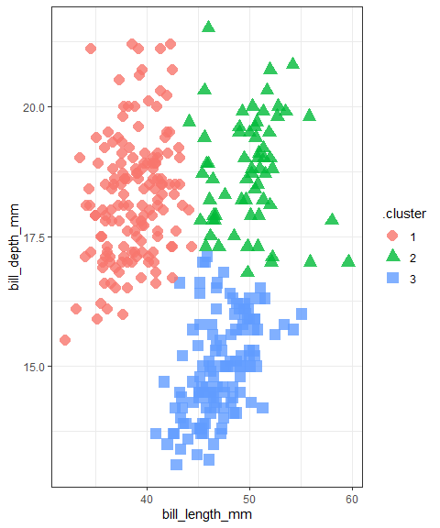

## Plot clusters, faceted by species?

ggplot(pen_aug,   
 aes(x = bill_length_mm, y = bill_depth_mm)) +  
 geom_point(aes(color = .cluster, shape = .cluster),   
 size = 4, alpha = 0.8) +  
 facet_wrap(~ species)

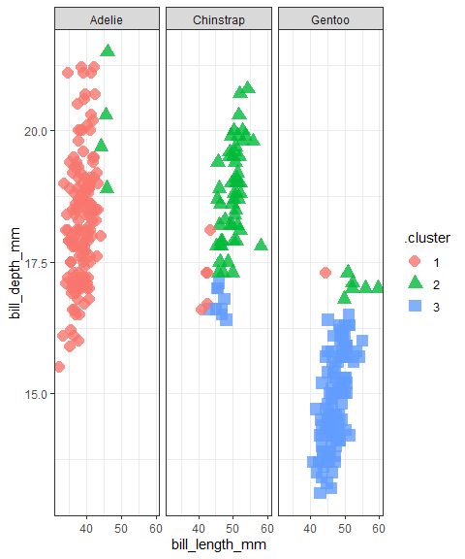

## Comparison of Cluster Results to Original species

pen_aug |> tabyl(.cluster, species)

.cluster Adelie Chinstrap Gentoo  
 1 147 5 1  
 2 4 54 6  
 3 0 9 116

## What if we used a different number of clusters?

p_clusts <-  
 tibble(k = 1:6) |>  
 mutate(  
 pclust = purrr::map(k, ~ kmeans(pen1, .x)),  
 ptidy = purrr::map(pclust, tidy),  
 pglance = purrr::map(pclust, glance),  
 paug = purrr::map(pclust, augment, pen))  
  
p_clusters <- p_clusts |> unnest(cols = c(ptidy))  
p_assigns <- p_clusts |> unnest(cols = c(paug))  
p_clusterings <- p_clusts |> unnest(cols = c(pglance))

## What do these clusters look like?

ggplot(p_assigns,   
 aes(x = bill_length_mm, y = bill_depth_mm)) +  
 geom_point(aes(color = .cluster), alpha = 0.8) +  
 facet_wrap(~ k)

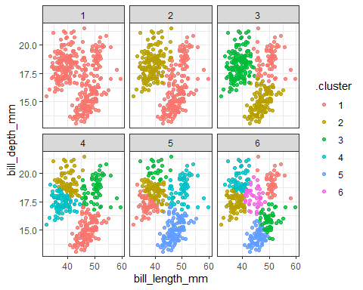

## Scree Plot to help choose best k

ggplot(p_clusterings, aes(x = k, y = tot.withinss)) +  
 geom_line() + geom_point()

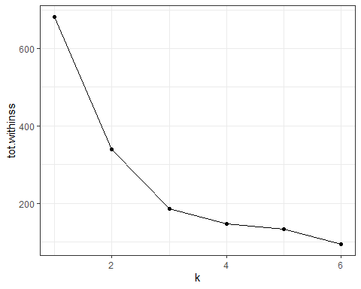

## Could we consider other penguin characteristics?

* Only if they are numeric.

pen_new <- penguins |>  
 select(flipper_length_mm, body_mass_g,   
 species, island) |>  
 drop_na()  
  
pen2 <- pen_new |> select(-species, -island) |> scale()  
  
pen_clust2 <- kmeans(pen2, centers = 3)

## Augment with the clusters, and tabulate

pen_aug2 <- augment(pen_clust2, pen_new)  
pen_aug2 |> tabyl(.cluster, species)

.cluster Adelie Chinstrap Gentoo  
 1 0 1 100  
 2 45 29 23  
 3 106 38 0

pen_aug2 |> tabyl(.cluster, island)

.cluster Biscoe Dream Torgersen  
 1 100 1 0  
 2 35 46 16  
 3 32 77 35

## Plot second set of clusters, facet by species

ggplot(pen_aug2,  
 aes(x = flipper_length_mm, y = body_mass_g)) +  
 geom_point(aes(color = .cluster, shape = .cluster),  
 size = 4, alpha = 0.8) +  
 facet_wrap(~ species)

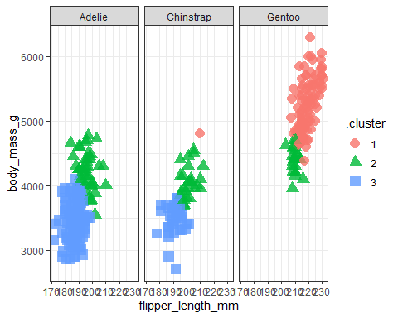

# Principal Components and the Palmer Penguins

## Principal Components Analysis (PCA)

The goal here is to summarize the information contained in a large set of variables by means of a smaller set of “summary index” values that can be more easily visualized and analyzed.

Statistically, PCA finds lines, planes and hyper-planes in K-dimensional space that approximate the data as well as possible, specifically by identifying components that maximize the variance of the projected data.

## Principal Components Analysis (PCA)

… in regression analysis, the larger the number of explanatory variables allowed, the greater is the chance of overfitting the model, producing conclusions that fail to generalise to other datasets. One approach, especially when there are strong correlations between different possible explanatory variables, is to reduce them to a few principal components and then run the regression against them, a method called principal component regression. (Wikipedia)

## Principal Components Analysis (PCA) on the Penguins?

Sure. See <https://allisonhorst.github.io/palmerpenguins/articles/pca.html> which is the basis for my next few slides.

We’ll build this within the tidymodels framework, and first use a few recipe steps to pre-process the data for PCA, specifically:

1. remove all NA values
2. center and scale all predictors

## Penguin PCA Recipe

penguin_recipe <-  
 recipe(~., data = penguins) |>  
 update_role(species, island, sex,   
 new_role = "id") |>  
 step_naomit(all_predictors()) |>  
 step_normalize(all_predictors()) |>  
 step_pca(all_predictors(), id = "pca") |>  
 prep()  
  
penguin_pca <-   
 penguin_recipe |>  
 tidy(id = "pca")

## Results for Penguin PCA

penguin_pca

# A tibble: 25 × 4  
 terms value component id   
 <chr> <dbl> <chr> <chr>  
 1 bill_length_mm 0.452 PC1 pca   
 2 bill_depth_mm -0.398 PC1 pca   
 3 flipper_length_mm 0.576 PC1 pca   
 4 body_mass_g 0.544 PC1 pca   
 5 year 0.0957 PC1 pca   
 6 bill_length_mm -0.0935 PC2 pca   
 7 bill_depth_mm 0.0164 PC2 pca   
 8 flipper_length_mm 0.0256 PC2 pca   
 9 body_mass_g -0.111 PC2 pca   
10 year 0.989 PC2 pca   
# ℹ 15 more rows

## An Easier-to-Use Presentation

penguins |>  
 dplyr::select(body_mass_g, ends_with("_mm")) |>  
 tidyr::drop_na() |> scale() |> prcomp()

Standard deviations (1, .., p=4):  
[1] 1.6594442 0.8789293 0.6043475 0.3293816  
  
Rotation (n x k) = (4 x 4):  
 PC1 PC2 PC3 PC4  
body_mass_g 0.5483502 0.084362920 0.5966001 0.5798821  
bill_length_mm 0.4552503 0.597031143 -0.6443012 0.1455231  
bill_depth_mm -0.4003347 0.797766572 0.4184272 -0.1679860  
flipper_length_mm 0.5760133 0.002282201 0.2320840 -0.7837987

## How much variance does each component account for?

penguin_recipe |>  
 tidy(id = "pca", type = "variance") |>  
 dplyr::filter(terms == "percent variance") |>  
 ggplot(aes(x = component, y = value)) +  
 geom_col(fill = "navy") +  
 xlim(c(0, 5)) +  
 ylab("% of total variance")

Warning: Removed 1 row containing missing values or values outside the scale range  
(`geom_col()`).

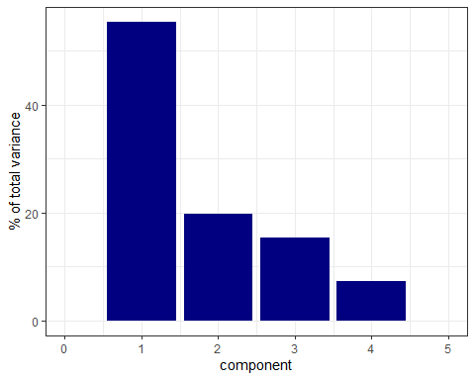

## Plot PCA Loadings

penguin_pca |>  
 mutate(terms = tidytext::reorder_within(terms,  
 abs(value),  
 component)) |>  
 ggplot(aes(abs(value), terms, fill = value > 0)) +  
 geom_col() +  
 facet_wrap(~component, scales = "free_y") +  
 tidytext::scale_y_reordered() +  
 scale_fill_manual(values = c("#b6dfe2", "#0A537D")) +  
 labs(  
 x = "Absolute value of contribution",  
 y = NULL, fill = "Positive?"  
 )

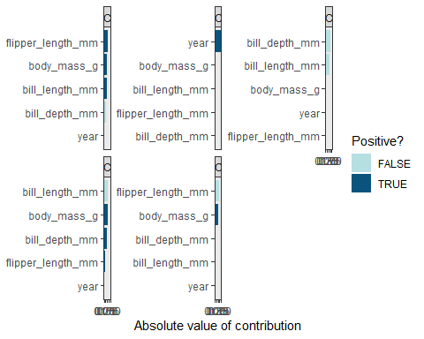

# K-Means Clustering with Arrests Data in US States

## The USArrests data, from base R

The USArrests data set from base R is a table containing the number of arrests per 100,000 residents in each US state in 1973 for Murder, Assault and Rape, along with the percentage of the population in each state that lives in urban areas, called UrbanPop.

USArr73 <- USArrests |>  
 mutate(state = row.names(USArrests)) |>  
 relocate(state) |>  
 as_tibble()  
  
n_miss(USArr73)

[1] 0

## The cleaned USArr73 tibble

USArr73

# A tibble: 50 × 5  
 state Murder Assault UrbanPop Rape  
 <chr> <dbl> <int> <int> <dbl>  
 1 Alabama 13.2 236 58 21.2  
 2 Alaska 10 263 48 44.5  
 3 Arizona 8.1 294 80 31   
 4 Arkansas 8.8 190 50 19.5  
 5 California 9 276 91 40.6  
 6 Colorado 7.9 204 78 38.7  
 7 Connecticut 3.3 110 77 11.1  
 8 Delaware 5.9 238 72 15.8  
 9 Florida 15.4 335 80 31.9  
10 Georgia 17.4 211 60 25.8  
# ℹ 40 more rows

## Scale each variable to have mean 0 and sd 1

USArr73_s <- USArr73 |> select(-state) |> scale()  
  
row.names(USArr73_s) <- row.names(USArrests)  
  
head(USArr73_s)

Murder Assault UrbanPop Rape  
Alabama 1.24256408 0.7828393 -0.5209066 -0.003416473  
Alaska 0.50786248 1.1068225 -1.2117642 2.484202941  
Arizona 0.07163341 1.4788032 0.9989801 1.042878388  
Arkansas 0.23234938 0.2308680 -1.0735927 -0.184916602  
California 0.27826823 1.2628144 1.7589234 2.067820292  
Colorado 0.02571456 0.3988593 0.8608085 1.864967207

## Fit 3-means clustering

kclust <- kmeans(USArr73_s, centers = 3)  
kclust

K-means clustering with 3 clusters of sizes 13, 29, 8  
  
Cluster means:  
 Murder Assault UrbanPop Rape  
1 0.6950701 1.0394414 0.72263703 1.27693964  
2 -0.7010700 -0.7071522 -0.09924526 -0.57773737  
3 1.4118898 0.8743346 -0.81452109 0.01927104  
  
Clustering vector:  
 Alabama Alaska Arizona Arkansas California   
 3 1 1 3 1   
 Colorado Connecticut Delaware Florida Georgia   
 1 2 2 1 3   
 Hawaii Idaho Illinois Indiana Iowa   
 2 2 1 2 2   
 Kansas Kentucky Louisiana Maine Maryland   
 2 2 3 2 1   
 Massachusetts Michigan Minnesota Mississippi Missouri   
 2 1 2 3 1   
 Montana Nebraska Nevada New Hampshire New Jersey   
 2 2 1 2 2   
 New Mexico New York North Carolina North Dakota Ohio   
 1 1 3 2 2   
 Oklahoma Oregon Pennsylvania Rhode Island South Carolina   
 2 2 2 2 3   
 South Dakota Tennessee Texas Utah Vermont   
 2 3 1 2 2   
 Virginia Washington West Virginia Wisconsin Wyoming   
 2 2 2 2 2   
  
Within cluster sum of squares by cluster:  
[1] 19.922437 53.354791 8.316061  
 (between_SS / total_SS = 58.4 %)  
  
Available components:  
  
[1] "cluster" "centers" "totss" "withinss" "tot.withinss"  
[6] "betweenss" "size" "iter" "ifault"

## Summary of 3-means clustering

summary(kclust)

Length Class Mode   
cluster 50 -none- numeric  
centers 12 -none- numeric  
totss 1 -none- numeric  
withinss 3 -none- numeric  
tot.withinss 1 -none- numeric  
betweenss 1 -none- numeric  
size 3 -none- numeric  
iter 1 -none- numeric  
ifault 1 -none- numeric

## Use augment() from broom

augment(kclust, USArr73_s)

# A tibble: 50 × 6  
 .rownames Murder Assault UrbanPop Rape .cluster  
 <chr> <dbl> <dbl> <dbl> <dbl> <fct>   
 1 Alabama 1.24 0.783 -0.521 -0.00342 3   
 2 Alaska 0.508 1.11 -1.21 2.48 1   
 3 Arizona 0.0716 1.48 0.999 1.04 1   
 4 Arkansas 0.232 0.231 -1.07 -0.185 3   
 5 California 0.278 1.26 1.76 2.07 1   
 6 Colorado 0.0257 0.399 0.861 1.86 1   
 7 Connecticut -1.03 -0.729 0.792 -1.08 2   
 8 Delaware -0.433 0.807 0.446 -0.580 2   
 9 Florida 1.75 1.97 0.999 1.14 1   
10 Georgia 2.21 0.483 -0.383 0.488 3   
# ℹ 40 more rows

## Use tidy() and glance() from broom

tidy(kclust)

# A tibble: 3 × 7  
 Murder Assault UrbanPop Rape size withinss cluster  
 <dbl> <dbl> <dbl> <dbl> <int> <dbl> <fct>   
1 0.695 1.04 0.723 1.28 13 19.9 1   
2 -0.701 -0.707 -0.0992 -0.578 29 53.4 2   
3 1.41 0.874 -0.815 0.0193 8 8.32 3

glance(kclust)

# A tibble: 1 × 4  
 totss tot.withinss betweenss iter  
 <dbl> <dbl> <dbl> <int>  
1 196 81.6 114. 2

## Use 1-9 clusters now

kclusts <-   
 tibble(k = 1:9) |>  
 mutate(  
 kclust = purrr::map(k, ~ kmeans(USArr73_s, .x)),  
 tidied = purrr::map(kclust, tidy),  
 glanced = purrr::map(kclust, glance),  
 augmented = purrr::map(kclust, augment, USArr73_s)  
 )

clusters <- kclusts |> unnest(cols = c(tidied))  
assignments <- kclusts |> unnest(cols = c(augmented))  
clusterings <- kclusts |> unnest(cols = c(glanced))

## Plots on Next Three Slides (code)

### Plot 1

ggplot(assignments, aes(x = UrbanPop, y = Murder)) +  
 geom_point(aes(color = .cluster), alpha = 0.8) +  
 facet_wrap(~ k)

### Plot 2

ggplot(assignments, aes(x = UrbanPop, y = Murder)) +  
 geom_point(aes(color = .cluster), alpha = 0.8) +  
 geom_point(data = clusters, size = 10, shape = "x") +  
 facet_wrap(~ k)

### Plot 3

ggplot(clusterings, aes(x = k, y = tot.withinss)) +  
 geom_line() + geom_point()

## Plot 1

ggplot(assignments, aes(x = UrbanPop, y = Murder)) +  
 geom_point(aes(color = .cluster), alpha = 0.8) +  
 facet_wrap(~ k)

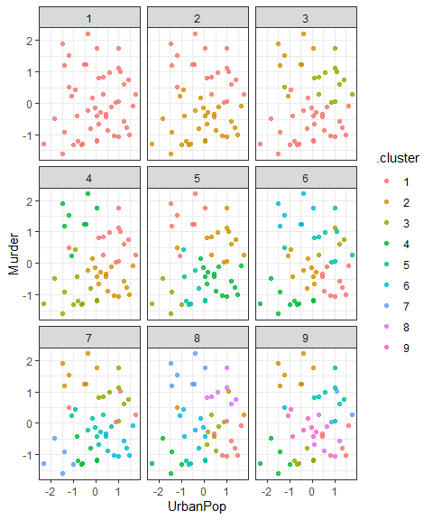

## Plot 2

ggplot(assignments, aes(x = UrbanPop, y = Murder)) +  
 geom_point(aes(color = .cluster), alpha = 0.8) +  
 geom_point(data = clusters, size = 10, shape = "x") +  
 facet_wrap(~ k)

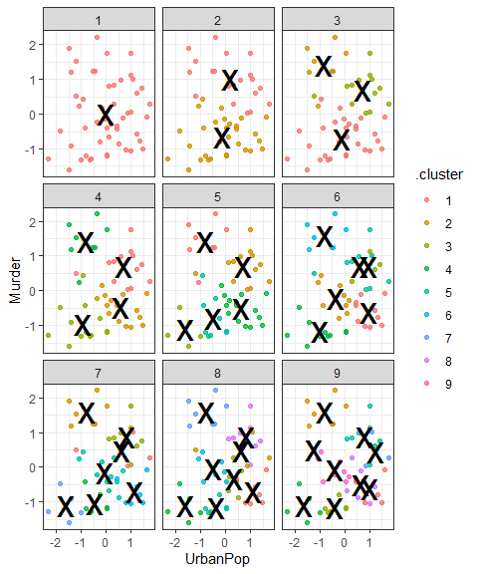

## Plot 3

ggplot(clusterings, aes(x = k, y = tot.withinss)) +  
 geom_line() + geom_point()

